# Record of change

|  |  |  |
| --- | --- | --- |
| **Date** | **Content** | **Version** |
| 15/01/2025 | Add Use Case diagram | 1.0 |
|  |  | 2.0 |
|  |  | 3.0 |

# REFERENCES

|  |  |
| --- | --- |
| **Document Name** | **Description** |
| RMS_SMS_sample_v1.0 | Create a framework to do the sample exercise |
|  |  |
|  |  |
|  |  |
|  |  |
|  |  |
|  |  |

# LIST OF PARTNERS AND TERMS

|  |  |
| --- | --- |
| **Name** | **Tittle** |
|  |  |
|  |  |
|  |  |
|  |  |
|  |  |
|  |  |
|  |  |
|  |  |
|  |  |

# Introduce

## Purpose

## *- Software helps businesses achieve high efficiency: management becomes simpler, more accurate and faster.*

## *- The topic helps us approach a new form in implementing a specific project in the future.*

## Scope

* *- Software for managing small and medium-sized restaurants with functions applied to a specific restaurant. The system specifically describes the tasks that need to be done in a restaurant model, and can perform the following tasks: staff management, food management/food classification, table management, table reservation management, order management, table management or menu list; in addition, there is also promotion management, revenue and expenditure management, statistical reporting data.*

# Overview

This software is designed to serve the management of Restaurants with access rights granted only to the following subjects: Administrator (as Manager), Customer (Customer with an account), Guest (Customer who comes in), Staff (as Salesperson) and Ktichen (as Kitchen Staff). Admin will create a list of accounts and Staff, Kitchen will use those accounts, and for customers, to access the system, they need to register an account on the restaurant's website. When the user logs in successfully, they will be able to access the system. Admin will have the right to perform all functions of the program, while other roles are limited to performing functions, specifically only being able to access functions in the sales category and their own accounts.

|  |  |  |
| --- | --- | --- |
| **#** | **Actor** | **Description** |
| 1 | Administrator | The web administrator is responsible for managing user accounts and managing system notifications, this person is the restaurant owner and is also responsible for managing dishes on the menu, can add, edit, delete dishes as well as manage tables, manage customers, manage statistical reports. |
| 2 | Kitchen | The kitchen Admin is assigned by the administrator, this person is responsible for receiving customer orders. After confirmation, this person will return to the customer the status of the dish that the customer has ordered. |
| 3 | Staff | The waiter is assigned by the administrator, this person is responsible for receiving the customer's order. After the customer finishes eating, ask this person to come to pay and the waiter can see what the customer ordered. |
| 4 | Guest | User not login in system, Guest need to scan the QR code on the table and fill in the information to see the menu |
| 5 | Customer | After scanning the QR code and filling in personal information, customers will be able to use all the restaurant's services such as viewing the menu, placing orders, and seeing how the order is completed,... |

## 

## Use Case Diagram

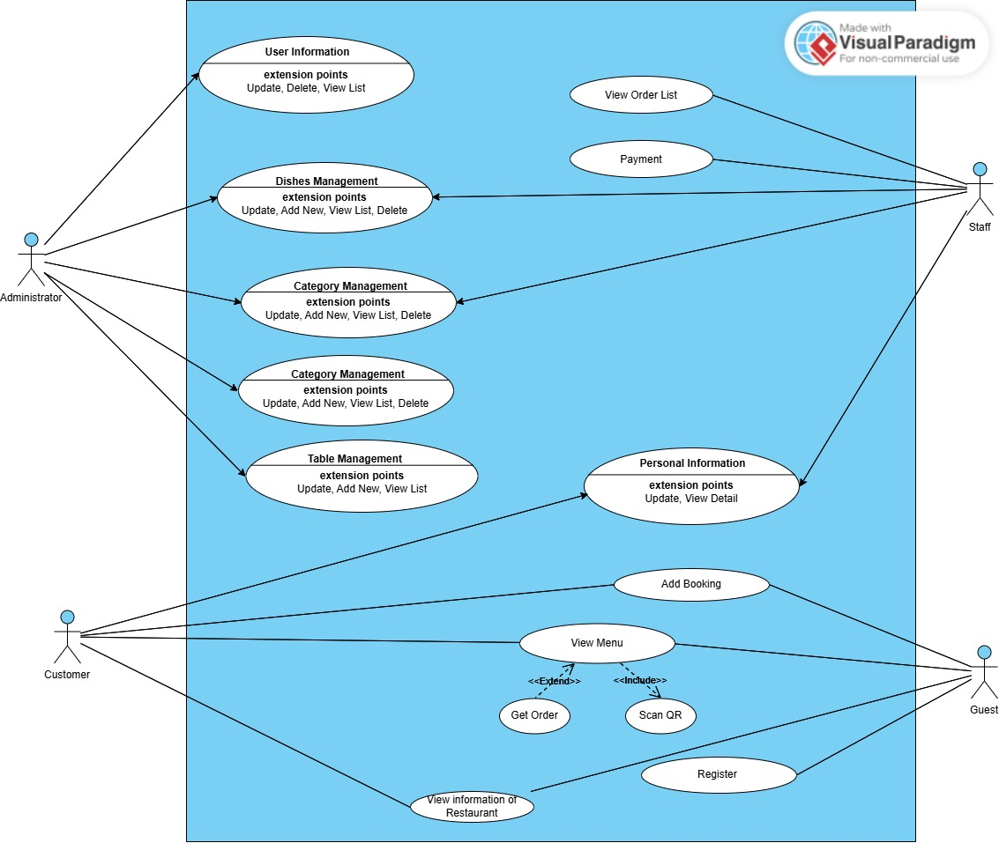

## Use Case Diagram for Staff

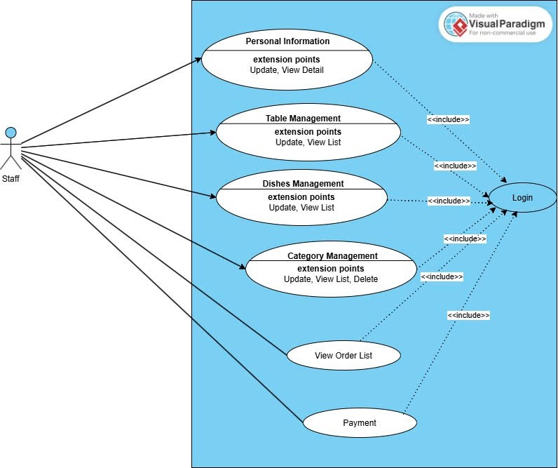

Use Case Diagram for Customer

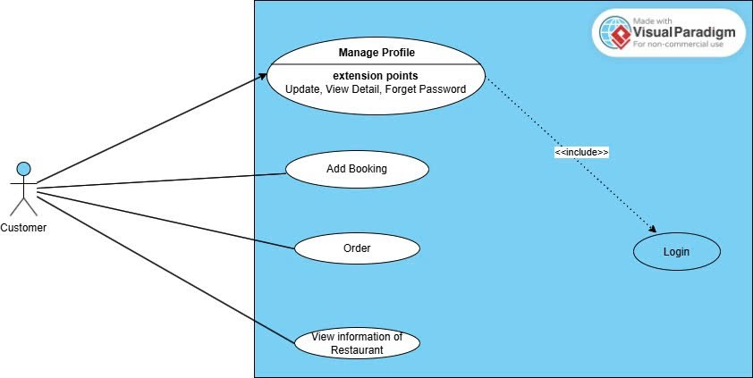

Use Case Diagram for Admin

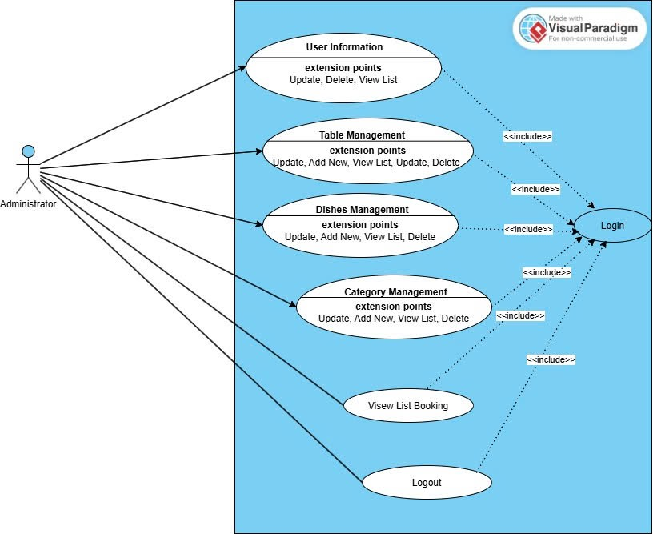

Use Case Diagram for Guest

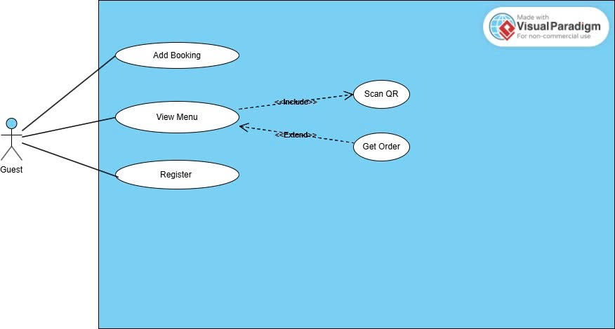

## Screen Flow

##### Customer Screen Flow Diagram

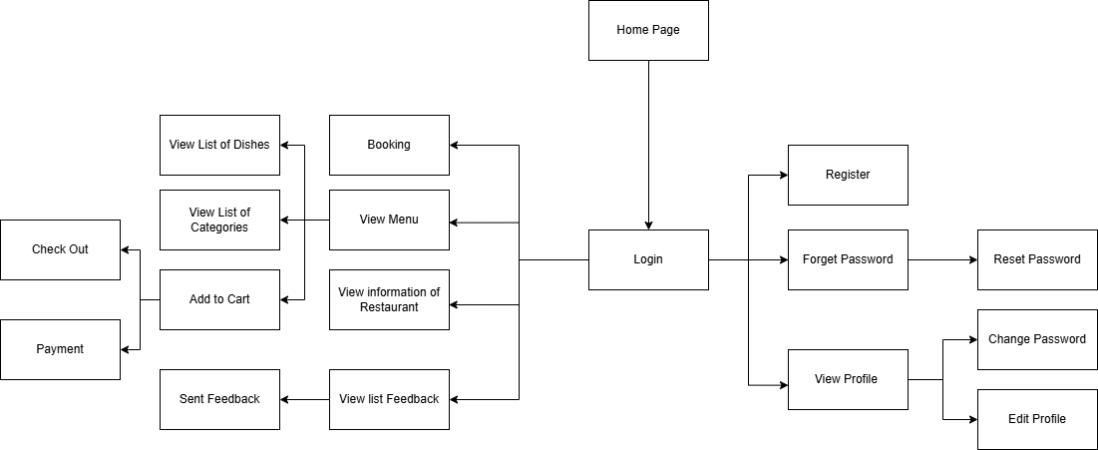

##### Admin Screen Flow Diagram

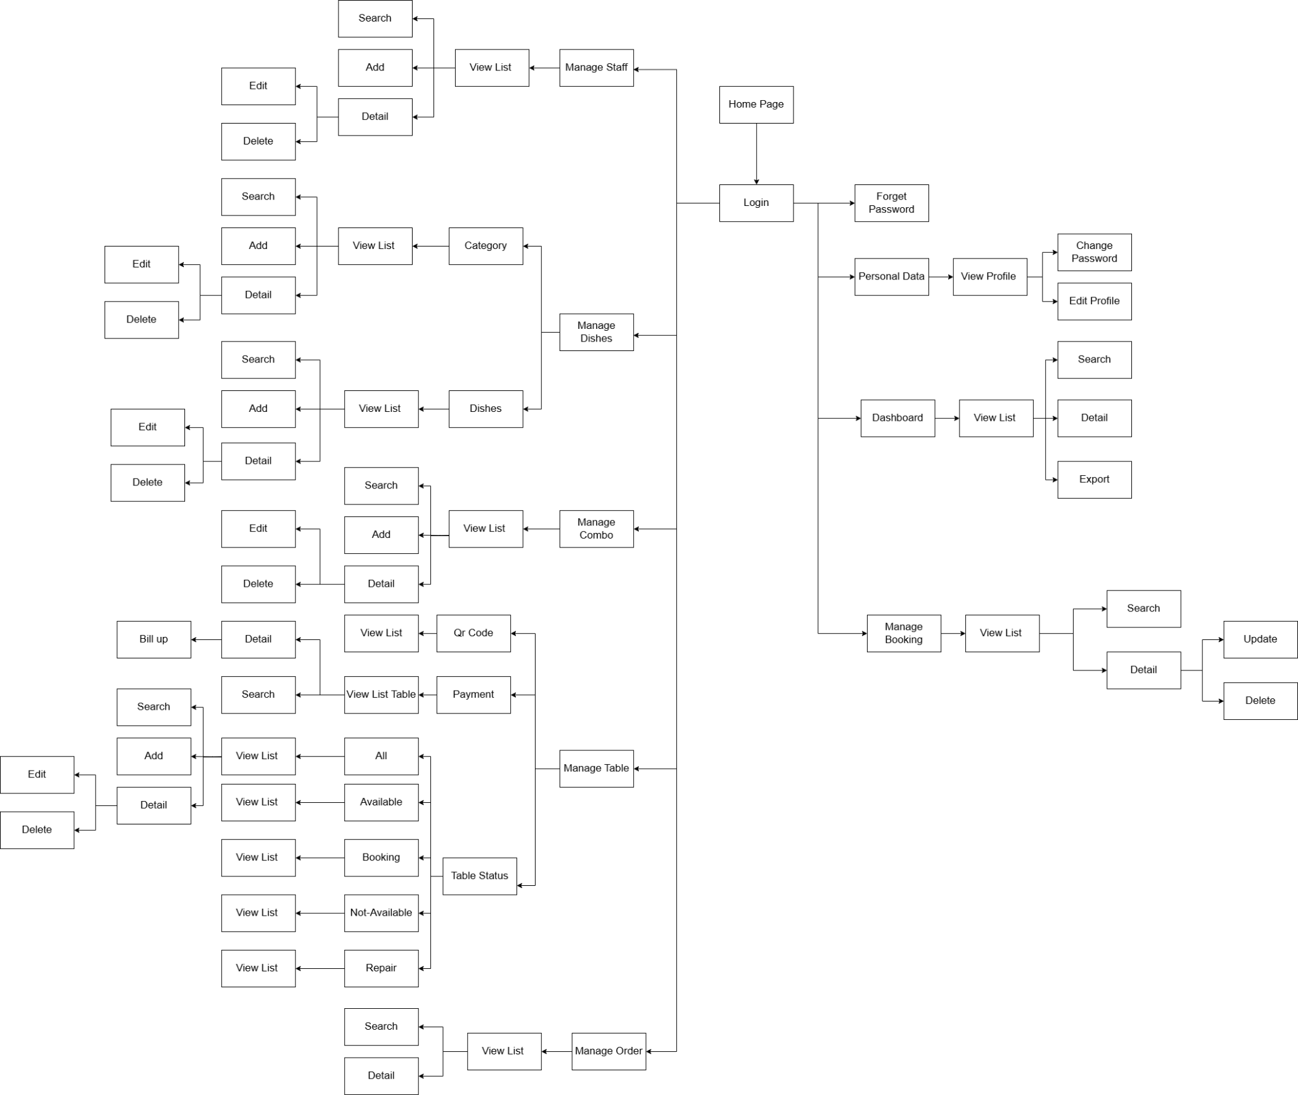

##### Guest Screen Flow Diagram

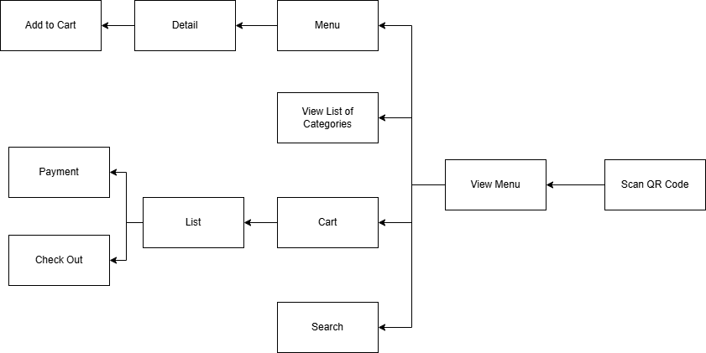

##### Staff Screen Flow Diagram

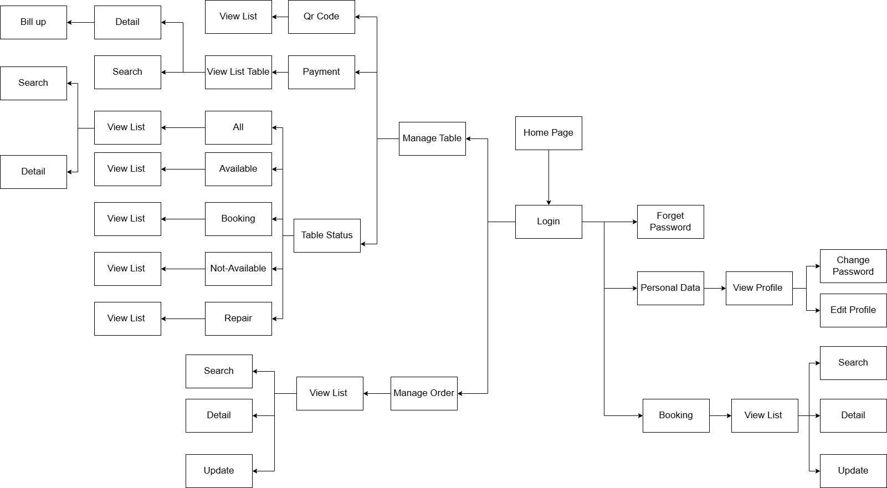

##### Kitchen Screen Flow Diagram

